**OLTPS (Business Data)** 

**Actionable Information**

**Business Intelligence (BI) Architecture**

Sharing

**Clients**

ETL

**Excel**

**OLAP (Analysis)**

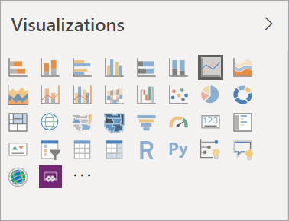

**SQL Server**

**Oracle**

Create Reports / Visuals

**OLAP**

**ETL – Extract, Transform & Load**

**OLTP – Online Transactional Processing**

**OLAP – Online Analytical Processing**